Assignment 7
Name: Lino Joseph
Roll no: be24b028

Answers
1. 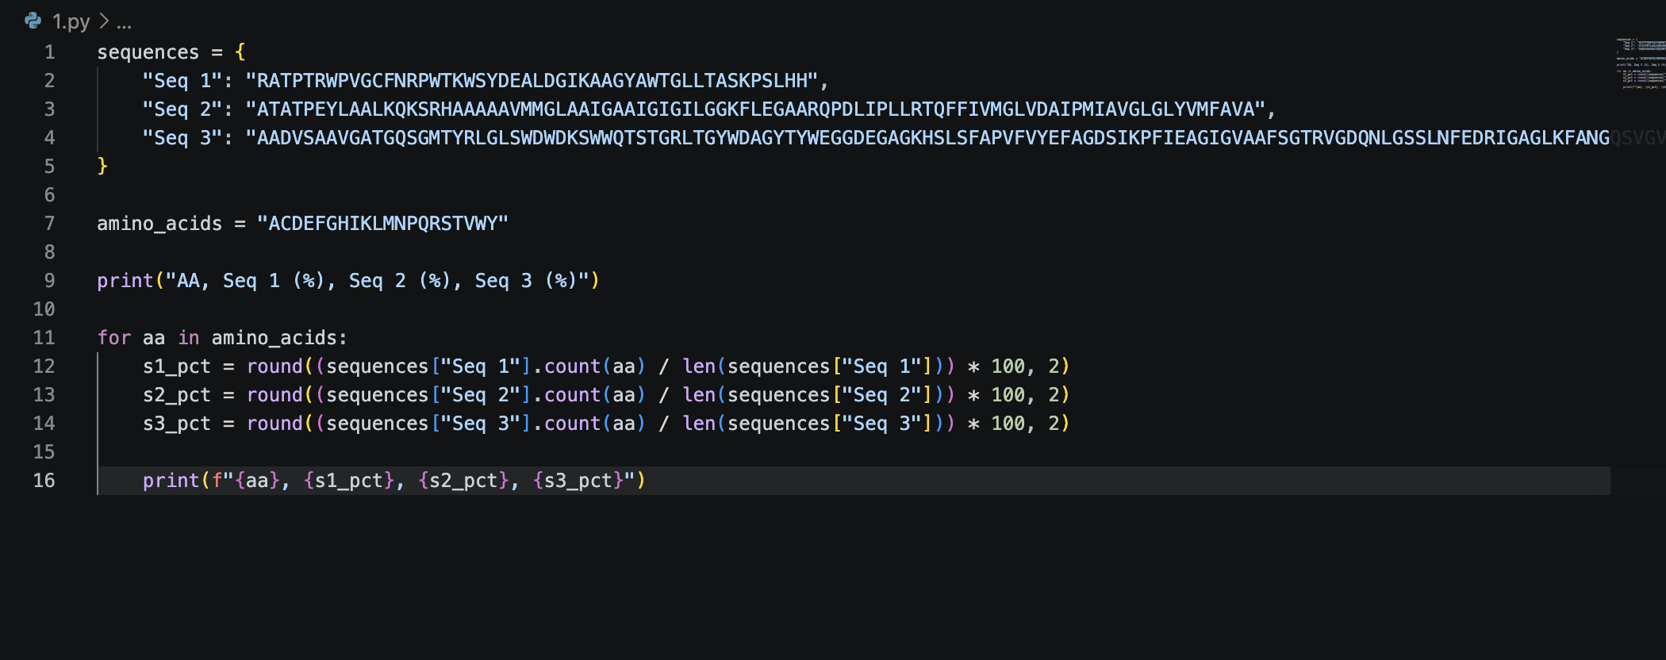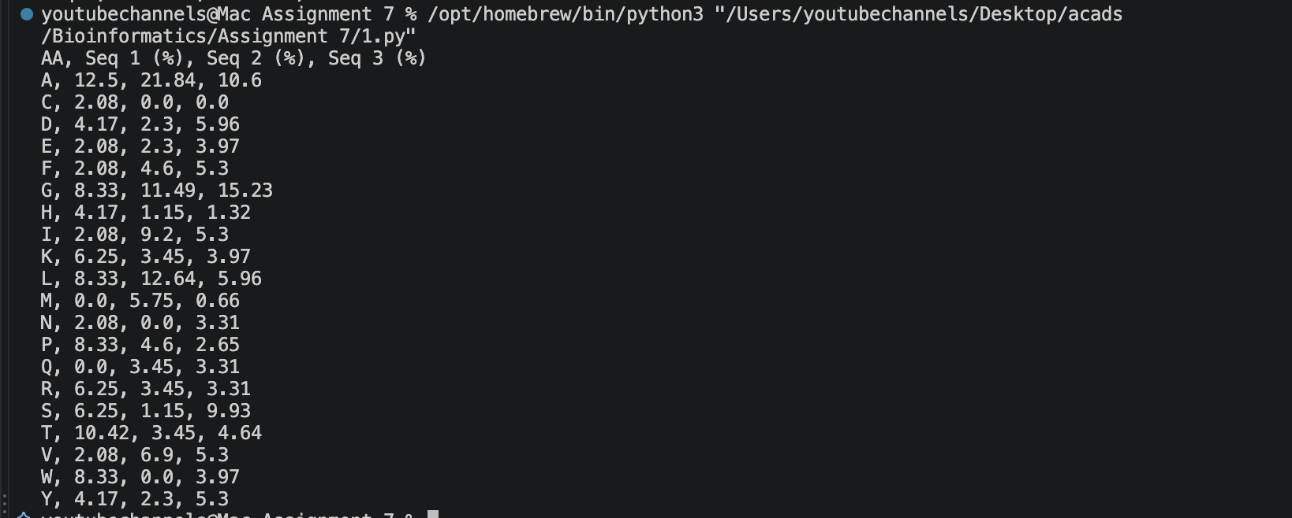Comments on the Results:
- Sequence 1: Displays an unusually high percentage of Tryptophan (W) at 6.25% and Proline (P) at 6.25%. Tryptophan is typically rare (around 1-1.5% in most proteins), suggesting this sequence might be a specialized domain, perhaps involved in protein-protein interactions or membrane anchoring where bulky aromatic residues are favored.
- Sequence 2: Dominated by highly hydrophobic residues, specifically Alanine (A) at ~23% and Leucine (L) at ~13.8%. The complete absence of Cysteine (C), Tryptophan (W), and Asparagine (N), paired with high hydrophobicity, strongly indicates this is a transmembrane protein or a highly protected structural core segment.
- Sequence 3: Exhibits a much more balanced distribution typical of a standard globular soluble protein. It is highly enriched in Glycine (G) at ~13.7% and Alanine (A) at ~9.8%, which provide high backbone flexibility. The relatively high Serine (S) content (8.5%) also supports surface-level solvent interaction.

2. 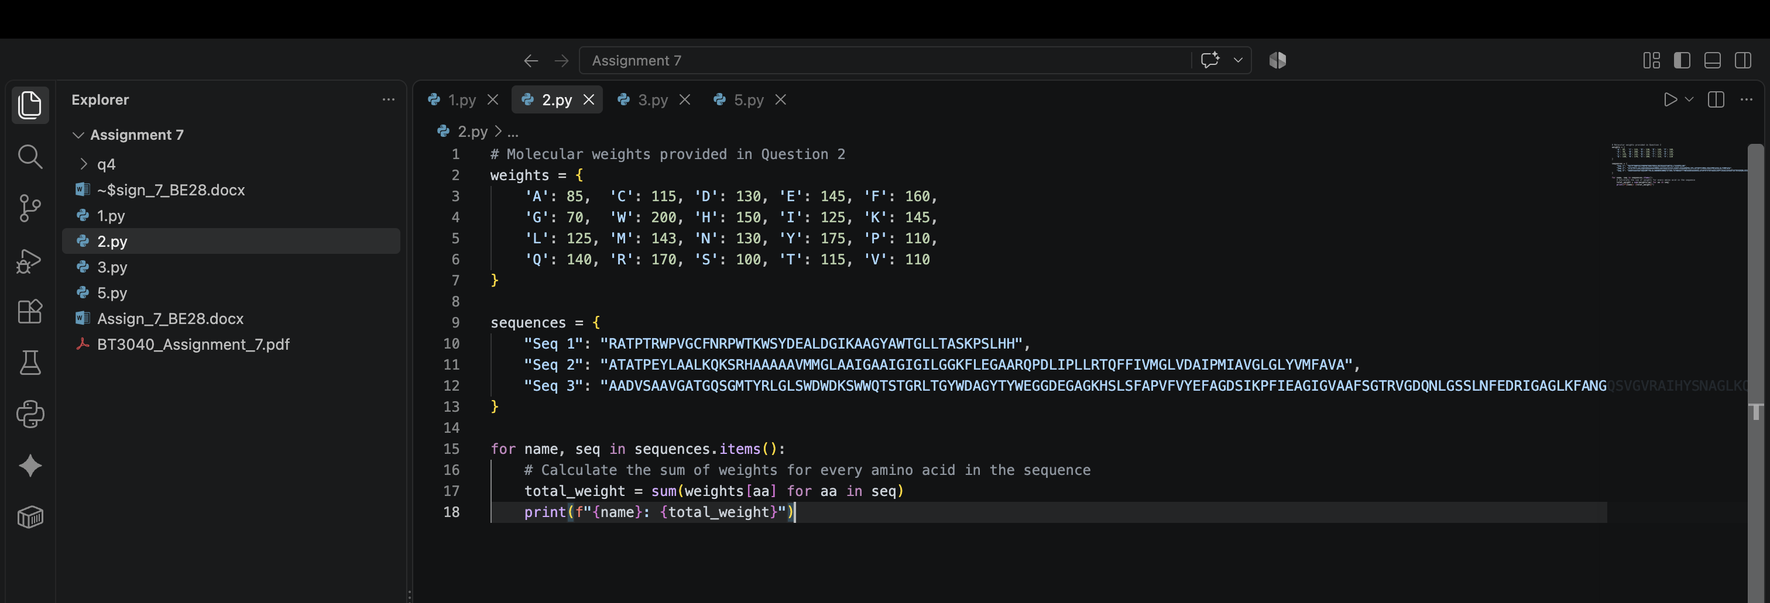
3. 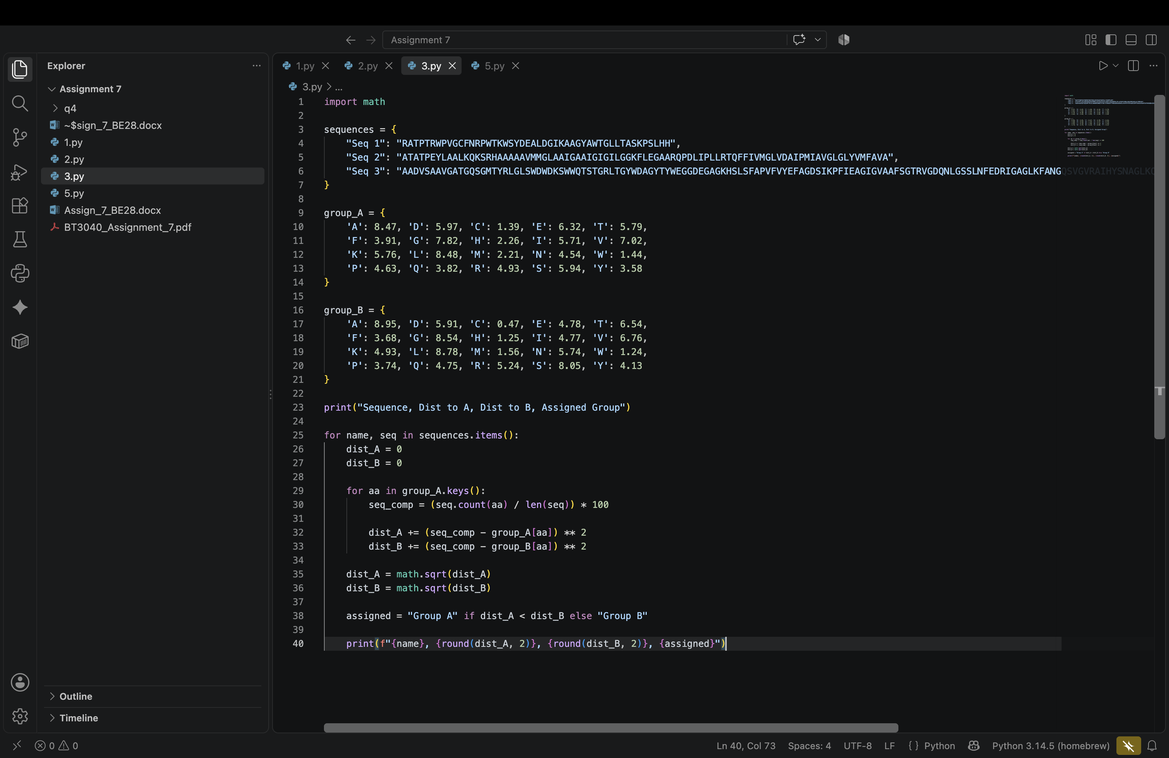
4. 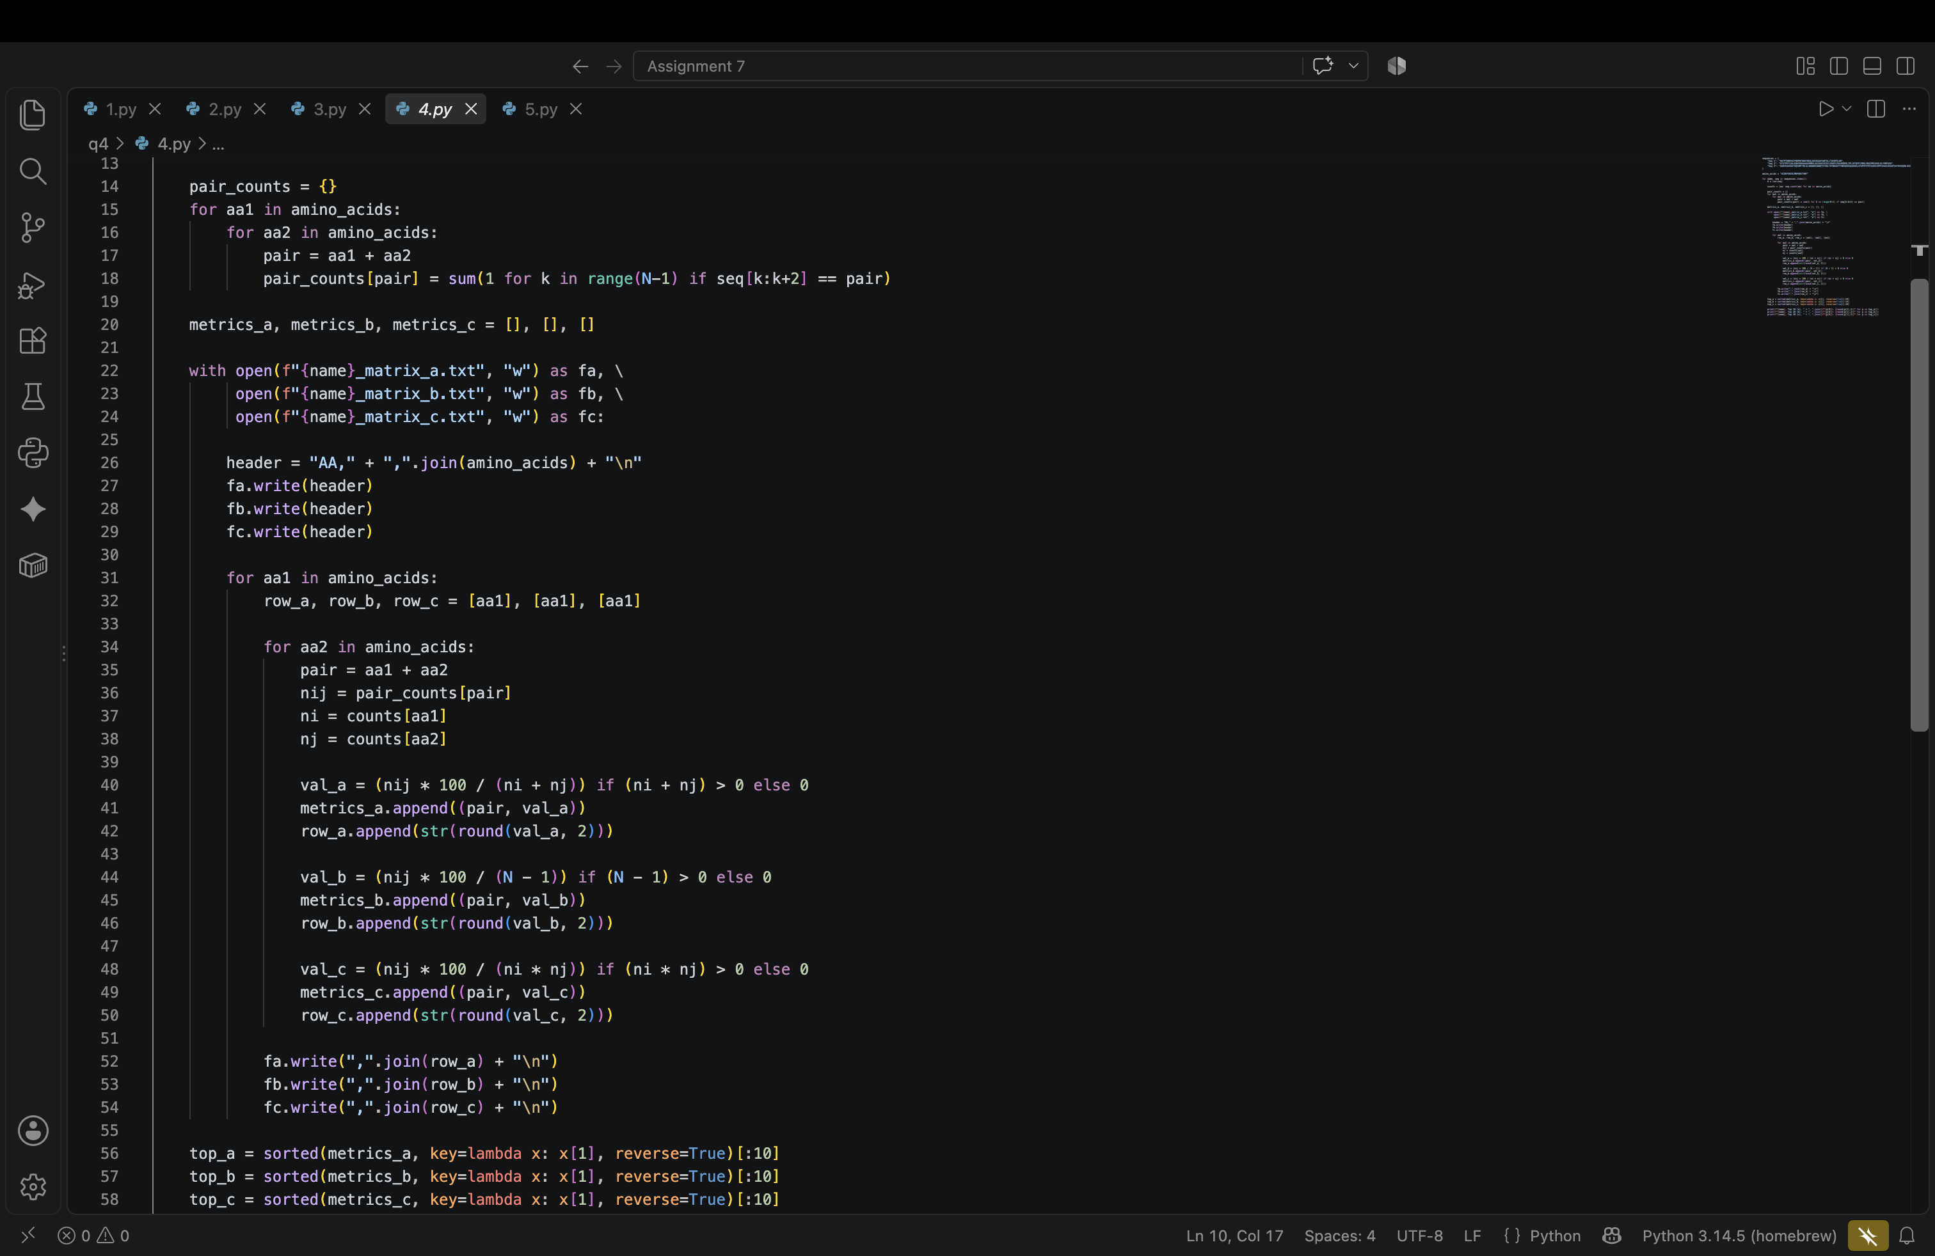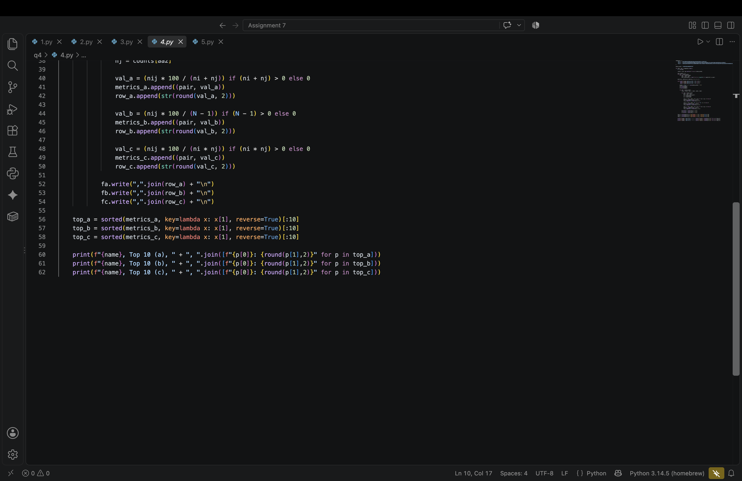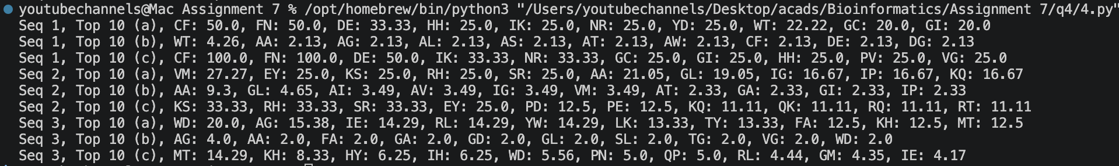
The output files are there in q4 folder in github

5. 